lab10

Ziyuan_Han

10/31/2021

#Class 10: Halloween Mini-Project

##Exploratory Analysis of Halloween Candy

#1. Importing candy data #<https://raw.githubusercontent.com/fivethirtyeight/data/master/candy-powerranking/candy-data.csv>

candy_file <- "https://raw.githubusercontent.com/fivethirtyeight/data/master/candy-power-ranking/candy-data.csv"  
candy = read.csv(candy_file, row.names=1)   
head(candy)

## chocolate fruity caramel peanutyalmondy nougat crispedricewafer  
## 100 Grand 1 0 1 0 0 1  
## 3 Musketeers 1 0 0 0 1 0  
## One dime 0 0 0 0 0 0  
## One quarter 0 0 0 0 0 0  
## Air Heads 0 1 0 0 0 0  
## Almond Joy 1 0 0 1 0 0  
## hard bar pluribus sugarpercent pricepercent winpercent  
## 100 Grand 0 1 0 0.732 0.860 66.97173  
## 3 Musketeers 0 1 0 0.604 0.511 67.60294  
## One dime 0 0 0 0.011 0.116 32.26109  
## One quarter 0 0 0 0.011 0.511 46.11650  
## Air Heads 0 0 0 0.906 0.511 52.34146  
## Almond Joy 0 1 0 0.465 0.767 50.34755

#Q1. How many different candy types are in this dataset?

85

nrow(candy)

## [1] 85

#Q2. How many fruity candy types are in the dataset? The functions dim(), nrow(), table() and sum() may be useful for answering the first 2 questions.

38

nrow(candy[candy$fruity == 1,])

## [1] 38

#What is your favorate candy?

candy["Twix", ]$winpercent

## [1] 81.64291

# What is your favorite candy in the dataset and what is it’s winpercent value?

ReeseÕs Peanut Butter cup: winpercent is 84.18029

candy["ReeseÕs Peanut Butter cup",]$winpercent

## [1] 84.18029

#What is the winpercent value for “Kit Kat”?

candy["Kit Kat",]$winpercent

## [1] 76.7686

#What is the winpercent value for “Tootsie Roll Snack Bars

candy["Tootsie Roll Snack Bars",]$winpercent

## [1] 49.6535

#install.packages("devtools")   
#devtools::install_github("ropensci/skimr")  
library("skimr")  
skim(candy)

Data summary

|  |  |
| --- | --- |
| Name | candy |
| Number of rows | 85 |
| Number of columns | 12 |
| _______________________ |  |
| Column type frequency: |  |
| numeric | 12 |
| ________________________ |  |
| Group variables | None |

**Variable type: numeric**

|  |  |  |  |  |  |  |  |  |  |  |
| --- | --- | --- | --- | --- | --- | --- | --- | --- | --- | --- |
| skim_variable | n_missing | complete_rate | mean | sd | p0 | p25 | p50 | p75 | p100 | hist |
| chocolate | 0 | 1 | 0.44 | 0.50 | 0.00 | 0.00 | 0.00 | 1.00 | 1.00 | ▇▁▁▁▆ |
| fruity | 0 | 1 | 0.45 | 0.50 | 0.00 | 0.00 | 0.00 | 1.00 | 1.00 | ▇▁▁▁▆ |
| caramel | 0 | 1 | 0.16 | 0.37 | 0.00 | 0.00 | 0.00 | 0.00 | 1.00 | ▇▁▁▁▂ |
| peanutyalmondy | 0 | 1 | 0.16 | 0.37 | 0.00 | 0.00 | 0.00 | 0.00 | 1.00 | ▇▁▁▁▂ |
| nougat | 0 | 1 | 0.08 | 0.28 | 0.00 | 0.00 | 0.00 | 0.00 | 1.00 | ▇▁▁▁▁ |
| crispedricewafer | 0 | 1 | 0.08 | 0.28 | 0.00 | 0.00 | 0.00 | 0.00 | 1.00 | ▇▁▁▁▁ |
| hard | 0 | 1 | 0.18 | 0.38 | 0.00 | 0.00 | 0.00 | 0.00 | 1.00 | ▇▁▁▁▂ |
| bar | 0 | 1 | 0.25 | 0.43 | 0.00 | 0.00 | 0.00 | 0.00 | 1.00 | ▇▁▁▁▂ |
| pluribus | 0 | 1 | 0.52 | 0.50 | 0.00 | 0.00 | 1.00 | 1.00 | 1.00 | ▇▁▁▁▇ |
| sugarpercent | 0 | 1 | 0.48 | 0.28 | 0.01 | 0.22 | 0.47 | 0.73 | 0.99 | ▇▇▇▇▆ |
| pricepercent | 0 | 1 | 0.47 | 0.29 | 0.01 | 0.26 | 0.47 | 0.65 | 0.98 | ▇▇▇▇▆ |
| winpercent | 0 | 1 | 50.32 | 14.71 | 22.45 | 39.14 | 47.83 | 59.86 | 84.18 | ▃▇▆▅▂ |

#Q6. Is there any variable/column that looks to be on a different scale to the majority of the other columns in the dataset? column 12 is inscale. So we have to scale the data when doing PCA otherwise this parameter is going to dominant over the rest.

#Q7. What do you think a zero and one represent for the candy$chocolate column? 0 and 1 represent boolean values False and True. Indicating the candy contains cholocate or not.

#Q8. Plot a histogram of winpercent values

library(ggplot2)   
data = candy   
data$type = rownames(data)   
ggplot(data, aes(x=winpercent)) + geom_histogram()

## `stat_bin()` using `bins = 30`. Pick better value with `binwidth`.

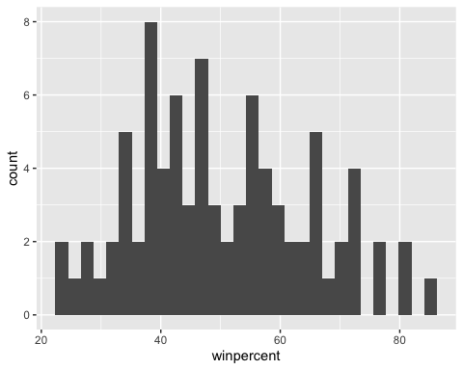 #Q9. Is the distribution of winpercent values symmetrical?

Yes

#Q10. Is the center of the distribution above or below 50%?

obove 50%

#Q11. On average is chocolate candy higher or lower ranked than fruit candy? cholocate candy rank higher than fruit candy

print(mean(candy$winpercent[as.logical(candy$chocolate)]))

## [1] 60.92153

choc=data[data$chocolate == 1,]   
ggplot(choc, aes(x=winpercent)) +   
 geom_histogram() + xlim(0,100)

## `stat_bin()` using `bins = 30`. Pick better value with `binwidth`.

## Warning: Removed 2 rows containing missing values (geom_bar).

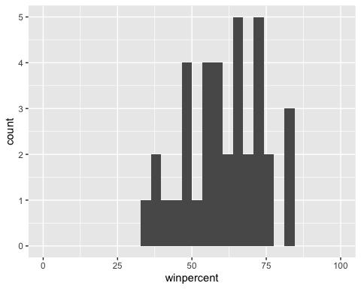

fruit=data[data$fruity == 1,]   
ggplot(fruit, aes(x=winpercent)) +   
 geom_histogram() + xlim(0,100)

## `stat_bin()` using `bins = 30`. Pick better value with `binwidth`.

## Warning: Removed 2 rows containing missing values (geom_bar).

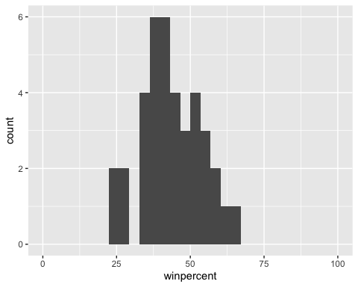 #Q12. Is this difference statistically significant? p-val of T-test is less than 0.05, indicating there is statistical significance between preferences for chocolate and fruity candy.

choc = candy$winpercent[as.logical(candy$chocolate)]   
fruit = candy$winpercent[as.logical(candy$fruity)]   
t.test(choc, fruit)

##   
## Welch Two Sample t-test  
##   
## data: choc and fruit  
## t = 6.2582, df = 68.882, p-value = 2.871e-08  
## alternative hypothesis: true difference in means is not equal to 0  
## 95 percent confidence interval:  
## 11.44563 22.15795  
## sample estimates:  
## mean of x mean of y   
## 60.92153 44.11974

#Overall Candy Rankings

library(dplyr)

##   
## Attaching package: 'dplyr'

## The following objects are masked from 'package:stats':  
##   
## filter, lag

## The following objects are masked from 'package:base':  
##   
## intersect, setdiff, setequal, union

candy %>% arrange(winpercent) %>% head(5)

## chocolate fruity caramel peanutyalmondy nougat  
## Nik L Nip 0 1 0 0 0  
## Boston Baked Beans 0 0 0 1 0  
## Chiclets 0 1 0 0 0  
## Super Bubble 0 1 0 0 0  
## Jawbusters 0 1 0 0 0  
## crispedricewafer hard bar pluribus sugarpercent pricepercent  
## Nik L Nip 0 0 0 1 0.197 0.976  
## Boston Baked Beans 0 0 0 1 0.313 0.511  
## Chiclets 0 0 0 1 0.046 0.325  
## Super Bubble 0 0 0 0 0.162 0.116  
## Jawbusters 0 1 0 1 0.093 0.511  
## winpercent  
## Nik L Nip 22.44534  
## Boston Baked Beans 23.41782  
## Chiclets 24.52499  
## Super Bubble 27.30386  
## Jawbusters 28.12744

head(candy[order(candy$winpercent),], n=5)

## chocolate fruity caramel peanutyalmondy nougat  
## Nik L Nip 0 1 0 0 0  
## Boston Baked Beans 0 0 0 1 0  
## Chiclets 0 1 0 0 0  
## Super Bubble 0 1 0 0 0  
## Jawbusters 0 1 0 0 0  
## crispedricewafer hard bar pluribus sugarpercent pricepercent  
## Nik L Nip 0 0 0 1 0.197 0.976  
## Boston Baked Beans 0 0 0 1 0.313 0.511  
## Chiclets 0 0 0 1 0.046 0.325  
## Super Bubble 0 0 0 0 0.162 0.116  
## Jawbusters 0 1 0 1 0.093 0.511  
## winpercent  
## Nik L Nip 22.44534  
## Boston Baked Beans 23.41782  
## Chiclets 24.52499  
## Super Bubble 27.30386  
## Jawbusters 28.12744

#Q13. What are the five least liked candy types in this set?

candy %>% arrange(winpercent) %>% head(5)

## chocolate fruity caramel peanutyalmondy nougat  
## Nik L Nip 0 1 0 0 0  
## Boston Baked Beans 0 0 0 1 0  
## Chiclets 0 1 0 0 0  
## Super Bubble 0 1 0 0 0  
## Jawbusters 0 1 0 0 0  
## crispedricewafer hard bar pluribus sugarpercent pricepercent  
## Nik L Nip 0 0 0 1 0.197 0.976  
## Boston Baked Beans 0 0 0 1 0.313 0.511  
## Chiclets 0 0 0 1 0.046 0.325  
## Super Bubble 0 0 0 0 0.162 0.116  
## Jawbusters 0 1 0 1 0.093 0.511  
## winpercent  
## Nik L Nip 22.44534  
## Boston Baked Beans 23.41782  
## Chiclets 24.52499  
## Super Bubble 27.30386  
## Jawbusters 28.12744

#Q14. What are the top 5 all time favorite candy types out of this set?

candy %>% arrange(desc(winpercent)) %>% head(5)

## chocolate fruity caramel peanutyalmondy nougat  
## ReeseÕs Peanut Butter cup 1 0 0 1 0  
## ReeseÕs Miniatures 1 0 0 1 0  
## Twix 1 0 1 0 0  
## Kit Kat 1 0 0 0 0  
## Snickers 1 0 1 1 1  
## crispedricewafer hard bar pluribus sugarpercent  
## ReeseÕs Peanut Butter cup 0 0 0 0 0.720  
## ReeseÕs Miniatures 0 0 0 0 0.034  
## Twix 1 0 1 0 0.546  
## Kit Kat 1 0 1 0 0.313  
## Snickers 0 0 1 0 0.546  
## pricepercent winpercent  
## ReeseÕs Peanut Butter cup 0.651 84.18029  
## ReeseÕs Miniatures 0.279 81.86626  
## Twix 0.906 81.64291  
## Kit Kat 0.511 76.76860  
## Snickers 0.651 76.67378

#Q15. Make a first barplot of candy ranking based on winpercent values. HINT: Use the aes(winpercent, rownames(candy)) for your first ggplot like so:

library(ggplot2)   
ggplot(candy) +  
aes(x=winpercent, y=rownames(candy)) +   
 geom_col()

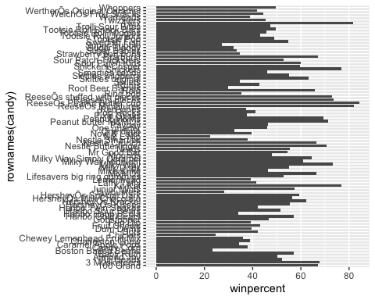 #Q16. This is quite ugly, use the reorder() function to get the bars sorted by winpercent? HINT: You can use aes(winpercent, reorder(rownames(candy),winpercent)) to improve your plot.

ggplot(candy) +  
aes(winpercent, reorder(rownames(candy),winpercent)) +   
 geom_col()

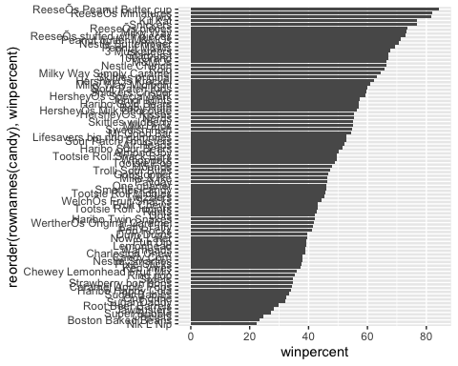

ggplot(candy) +  
aes(winpercent, reorder(rownames(candy),winpercent)) +   
 geom_col()

 #Q17. What is the worst ranked chocolate candy? sixlets

ggplot(candy) +  
aes(winpercent, reorder(rownames(candy),winpercent))

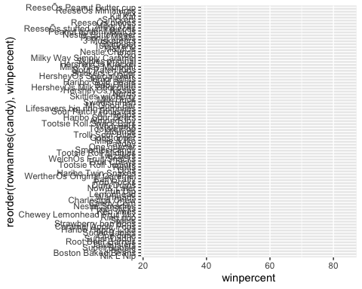

#Q18. What is the best ranked fruity candy? starburst

#Taking a look at pricepercent

library(ggrepel)  
aes(winpercent, pricepercent, label=rownames(candy)) +   
 geom_text_repel(size=3.3, max.overlaps = 5)

## NULL

#Q19. Which candy type is the highest ranked in terms of winpercent for the least money - i.e. offers the most bang for your buck? HersheyÕs Krackel

#Q20. What are the top 5 most expensive candy types in the dataset and of these which is the least popular? Nik L Nip

ord <- order(candy$pricepercent, decreasing = TRUE)   
head( candy[ord,c(11,12)], n=5 )

## pricepercent winpercent  
## Nik L Nip 0.976 22.44534  
## Nestle Smarties 0.976 37.88719  
## Ring pop 0.965 35.29076  
## HersheyÕs Krackel 0.918 62.28448  
## HersheyÕs Milk Chocolate 0.918 56.49050

#5 Exploring the correlation structure Now that we’ve explored the dataset a little, we’ll see how the variables interact with one another. We’ll use correlation and view the results with the corrplot package to plot a correlation matrix.

library(corrplot)

## corrplot 0.84 loaded

cij <- cor(candy)   
corrplot(cij)

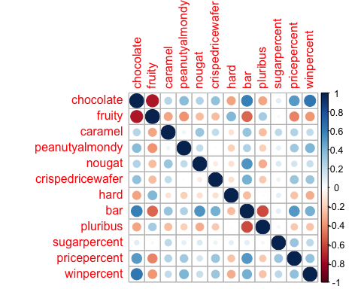 #Q22. Examining this plot what two variables are anti-correlated (i.e. have minus values)? fruity and chocolate #Q23. Similarly, what two variables are most positively correlated? winpercent and chocolate

#Principal Component Analysis

pca <- prcomp(candy, scale.=TRUE)   
summary(pca)

## Importance of components:  
## PC1 PC2 PC3 PC4 PC5 PC6 PC7  
## Standard deviation 2.0788 1.1378 1.1092 1.07533 0.9518 0.81923 0.81530  
## Proportion of Variance 0.3601 0.1079 0.1025 0.09636 0.0755 0.05593 0.05539  
## Cumulative Proportion 0.3601 0.4680 0.5705 0.66688 0.7424 0.79830 0.85369  
## PC8 PC9 PC10 PC11 PC12  
## Standard deviation 0.74530 0.67824 0.62349 0.43974 0.39760  
## Proportion of Variance 0.04629 0.03833 0.03239 0.01611 0.01317  
## Cumulative Proportion 0.89998 0.93832 0.97071 0.98683 1.00000

plot(pca$x[,1:2])

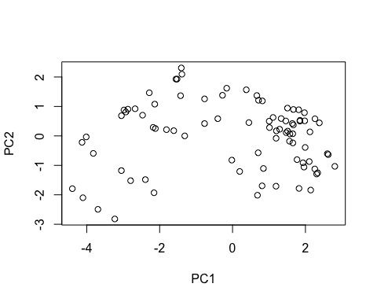

plot(pca$x[,1:2], pch=16)

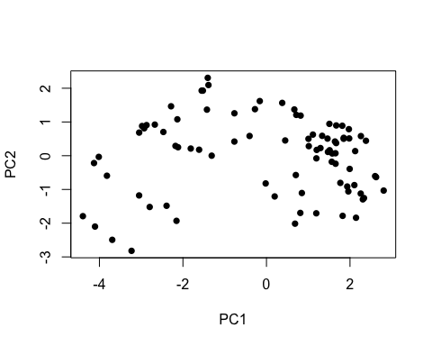

my_data <- cbind(candy, pca$x[,1:3])  
p <- ggplot(my_data) +  
aes(x=PC1, y=PC2, size=winpercent/100, text=rownames(my_data), label=rownames(my_data))   
p

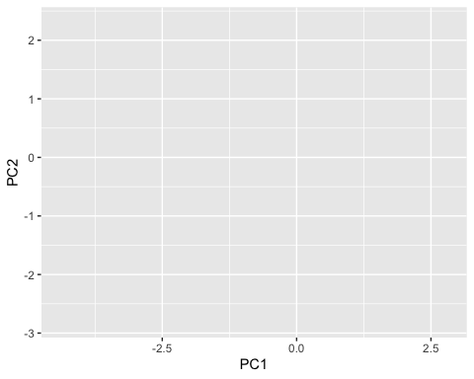

library(ggrepel)  
p + geom_text_repel(size=3.3, max.overlaps = 7)

## Warning: ggrepel: 55 unlabeled data points (too many overlaps). Consider  
## increasing max.overlaps

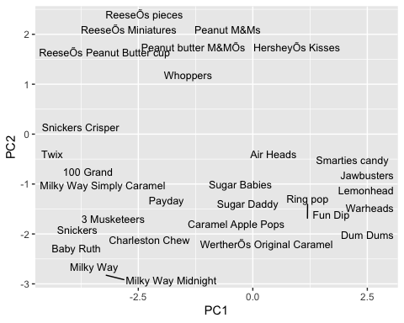

theme(legend.position = "none") + labs(title="Halloween Candy PCA Space",subtitle="Colored by type: chocolate bar (dark brown), chocolate other (light brown), fruity (red)",caption="Data from 538")

## List of 4  
## $ legend.position: chr "none"  
## $ title : chr "Halloween Candy PCA Space"  
## $ subtitle : chr "Colored by type: chocolate bar (dark brown), chocolate other (light brown), fruity (red)"  
## $ caption : chr "Data from 538"  
## - attr(*, "class")= chr [1:2] "theme" "gg"  
## - attr(*, "complete")= logi FALSE  
## - attr(*, "validate")= logi TRUE

par(mar=c(8,4,2,2))   
barplot(pca$rotation[,1], las=2, ylab="PC1 Contribution")

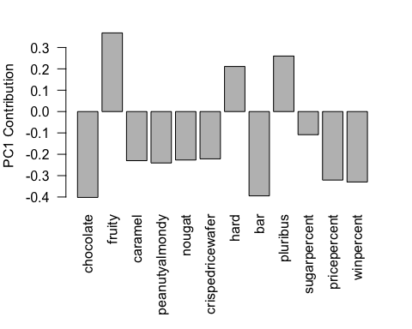 #Q24. What original variables are picked up strongly by PC1 in the positive direction? Do these make sense to you? HINT. pluribus means the candy comes in a bag or box of multiple candies.

fruity, hard, pluribus. yes